Template for the JSNDS annual conference abstract

Nature University Alex Nature, 〇Alice Forest
Institute of Nature Betty River
Keywords: New format, abstract, proceedings

- Introduction
This document explains how to write an abstract for the JSNDS annual conference. The contents of a presentation must not have been published previously. Objectives, theories and conclusions should be described according to the short abstract that is submitted for application so that all participants can understand them.
- Abstract format
The abstract should consist of 2 pages of A4 portrait. The details are as follows. Note that this guidance document is written according to the format described here.
(1) Word-processing software such as MS-WORD should be used.
(2) The contents should be aligned with 42 lines a page with 48 letters a line. There should be a margin of 18 mm above and below, and a margin of 15 mm on the left and right sides.
(3) The presentation title should be written in Times New Roman 12 pt and shown centering on the first line on the first page. Following the title, one blank line, author names and affiliation (please place 〇 to show the presenter if there is more than one author) should be shown aligned to the right. The main body should be located after 3~5 keywords and one blank line are placed after the author information. It is not necessary to have blank lines between chapters.
(4) Times New Roman 10 pt should be used for the main body and the captions.
(5) Figures and photos of sufficient resolution should be positioned directly in the main body. They should be numbered Figure 1, Figure 2, …, according to the order in which they appear. The captions for figures and photos should be placed on the lower and upper sides of them, respectively.
(6) Arabic numerals and SI units should be used.
- How to cite references
In citing references, a number with a right parenthesis should be added to the corresponding position. The number should be given in the order of appearance in the main body. The same number denotes the same reference. When more than one reference is cited, 1), 2), … or 2) ~ 5) should be written. References should be listed at the end of the main body. The reference format should follow that of the “Journal of Natural Disaster Science.” The references in this guidance document follow the same rules. The title of the paper should not be capitalized.
- Concluding remarks
The authors are requested to follow the rules and submit good-quality abstracts.
References
1) Babb, A. F., J. P. Schneider and T. Kenneth: Air flow in combined intake and spillway, Proc. ASCE, Vol. 99, HY7, pp. 1097-1108, 1980.
2) Adachi, T., F. Oka and M. Mimura: Mathematical structure of an overstress elasto-viscoplastic model for clay, Soils and Foundations, Vol. 27, No. 4, pp. 31-42, 1987.
3) Adachi, T., F. Oka and M. Mimura: An elasto-viscoplastic theory for clay failure, Proc. 8th Asian Regional Conf., SMFE, Vol. 1, pp. 5-8, 1987.

Table-1 Daily participants.
Date | 1/1 | 1/2 | 1/3 | 1/4 | 1/5 | 1/6
The number of participants | 4120 | 2534 | 3511 | 3942 | 3282 | 1889

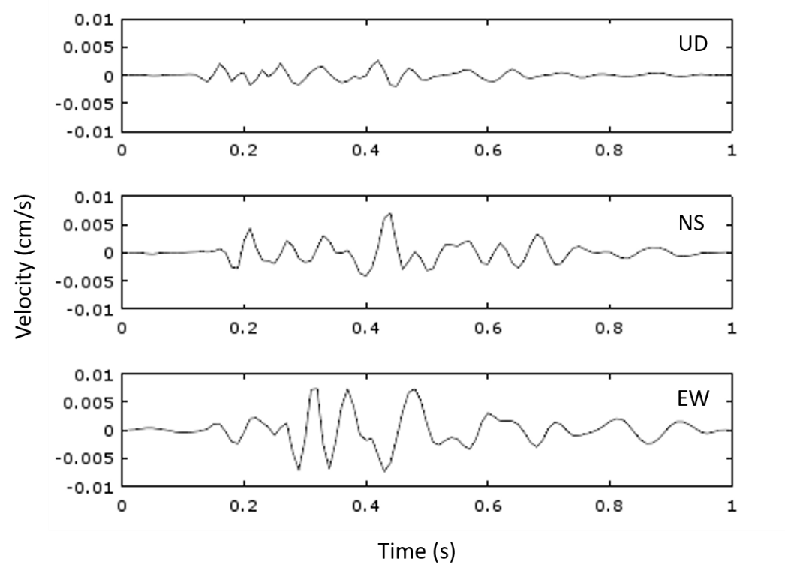

Figure-1 Seismic waveforms in three components with an impact of a hammer.

